**Standard Deviation and Variance**

Standard deviation is the average amount of variability in your data set. It tells you, on average, how far each score lies from the mean. If you end up with a high standard deviation, the values are far from the mean. If you end up with a low standard deviation, the values are clustered close to the mean. The formula for standard deviation consists of computing the mean of the data values and then finding the deviations of each data value from the mean. The equation stated, σ = √(∑(x−¯x)2/n), will be used when the mean from the data observations is found. “n” represents the total number of observations. Variance is the average squared deviation from the mean. To find the variance you find the mean of the set of numbers, then for each number subtract the mean and square the difference. Then lastly find the average of the squared differences. Variance has two equations that can be used. If you collected data from a population, then you use the population equation. 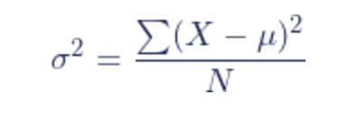 E – the sum of, X – each value, \mu - population mean, and N – number of values in the population. If you only have data from a sample of a population, then you use the sample equation. A mathematical equation with numbers
s^2 – sample variance, E – sum of, X – each value, \bar{x} - sample mean, n – number of values in the sample. An easy way to find the standard deviation is to just find the square root of the variance. Variance is not sub-additive, and the standard deviation is a measure of spread for symmetrical distributions with no outliers. Variance also measures the volatility of data of a population, standard deviation in finance is referred to as volatility.